Constructing Curve

Definition
# Source: AI Source: Provided by: [Data Path: Persons Table -> ID Column: 1, Name_En Column: Motasem Essam] -> From: [ChatGPT] on [7/25/2026]
Constructing a Curve is the process of creating a continuous geometric path that may change direction smoothly or through defined geometric segments.
A curve is a geometric object representing a continuous path of points. It may be straight, circular, conic, polynomial, spiral, or freeform depending on its defining properties.
In geometric construction, a curve is usually created by:
- Constructing a sequence of points.
- Connecting points with arcs.
- Using a mathematical equation.
- Using geometric constraints.
- Combining simpler curves.

Fundamental Concept
# Source: AI Source: Provided by: [Data Path: Persons Table -> ID Column: 1, Name_En Column: Motasem Essam] -> From: [ChatGPT] on [7/25/2026]
A curve can be represented parametrically as:
$$\boxed{P\left(t\right)=\left(x , \left(t\right)y\left(t\right)\right)}$$
where $t$is a parameter.
For an implicitly defined curve:
$$\boxed{F\left(x , y\right)=0}$$
For a polar curve:
$$\boxed{r=f\left(θ\right)}$$
The appropriate representation depends on the type of curve being constructed.

Main Construction Methods

1. Point-Based Construction
# Source: AI Source: Provided by: [Data Path: Persons Table -> ID Column: 1, Name_En Column: Motasem Essam] -> From: [ChatGPT] on [7/25/2026]
A curve can be constructed by determining a sequence of points that lie on the desired curve.
Steps
- Establish the required geometric framework.
- Select values for the relevant parameter.
- Construct the corresponding points.
- Plot or mark the points.
- Connect the points using the appropriate smooth curve.
If:
$$P_{1},P_{2},P_{3},…,P_{n}$$
are points on the curve, the curve can be approximated by connecting them smoothly.
This method is useful for curves that are difficult to construct directly.

2. Circular-Arc Construction
# Source: AI Source: Provided by: [Data Path: Persons Table -> ID Column: 1, Name_En Column: Motasem Essam] -> From: [ChatGPT] on [7/25/2026]
A curve can be constructed from connected circular arcs.
Steps
- Determine the required endpoints.
- Construct the centers of the arcs.
- Determine the required radii.
- Draw the arcs using a compass.
- Join consecutive arcs.
- Verify continuity at the joining points.
This method is common in technical drawing and mechanical design.

3. Conic Construction
# Source: AI Source: Provided by: [Data Path: Persons Table -> ID Column: 1, Name_En Column: Motasem Essam] -> From: [ChatGPT] on [7/25/2026]
Conic curves can be constructed from their defining geometric properties.
The principal conics are:
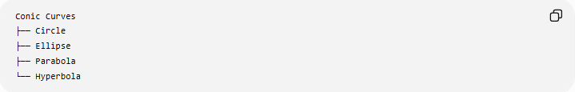
Conic Curves
├── Circle
├── Ellipse
├── Parabola
└── Hyperbola
Examples:
Circle
$$\boxed{{\left(x-h\right)}^{2}+{\left(y-k\right)}^{2}=r^{2}}$$
Ellipse
$$\boxed{\frac{{\left(x-h\right)}^{2}}{a^{2}}+\frac{{\left(y-k\right)}^{2}}{b^{2}}=1}$$
Parabola
$$\boxed{{\left(y-k\right)}^{2}=4p\left(x-h\right)}$$
Hyperbola
$$\boxed{\frac{{\left(x-h\right)}^{2}}{a^{2}}-\frac{{\left(y-k\right)}^{2}}{b^{2}}=1}$$

4. Spiral Construction
# Source: AI Source: Provided by: [Data Path: Persons Table -> ID Column: 1, Name_En Column: Motasem Essam] -> From: [ChatGPT] on [7/25/2026]
A spiral is a curve whose distance from its center changes as its angular position changes.
Its general polar form is:
$$\boxed{r=f\left(θ\right)}$$
Examples include:
- Archimedean spiral
- Logarithmic spiral
- Hyperbolic spiral
- Fermat's spiral
- Lituus
A Golden Spiral is a special logarithmic spiral.

5. Polynomial and Function-Based Construction
# Source: AI Source: Provided by: [Data Path: Persons Table -> ID Column: 1, Name_En Column: Motasem Essam] -> From: [ChatGPT] on [7/25/2026]
A curve can be constructed from a mathematical function.
For example:
$$\boxed{y=f\left(x\right)}$$
A simple quadratic curve is:
$$y=x^{2}$$
Construction
- Select values of $x$.
- Calculate the corresponding values of $y$.
- Plot the points.
- Connect them smoothly.
For example:
$$\begin{matrix}x & y=x^{2} \\ -2 & 4 \\ -1 & 1 \\ 0 & 0 \\ 1 & 1 \\ 2 & 4\end{matrix}$$
The resulting curve is a parabola.

6. Freeform Curve Construction
# Source: AI Source: Provided by: [Data Path: Persons Table -> ID Column: 1, Name_En Column: Motasem Essam] -> From: [ChatGPT] on [7/25/2026]
A freeform curve is constructed without requiring the curve to follow a single standard mathematical equation.
It may be created using:
- Selected control points.
- Smooth interpolation.
- Bézier curves.
- Splines.
- Connected arcs.
- Design constraints.
Freeform curves are common in:
- Computer graphics.
- Industrial design.
- Architecture.
- Product design.

7. Bézier Curve Construction
# Source: AI Source: Provided by: [Data Path: Persons Table -> ID Column: 1, Name_En Column: Motasem Essam] -> From: [ChatGPT] on [7/25/2026]
A Bézier curve is a mathematically defined curve controlled by a set of control points.
For a quadratic Bézier curve:
$$\boxed{B\left(t\right)={\left(1-t\right)}^{2}P_{0}+2\left(1-t\right)tP_{1}+t^{2}P_{2}}$$
where:
$$0≤t≤1$$
and:
- $P_{0}$= starting point.
- $P_{1}$= control point.
- $P_{2}$= ending point.
A cubic Bézier curve uses four control points:
$$\boxed{B\left(t\right)={\left(1-t\right)}^{3}P_{0}+3{\left(1-t\right)}^{2}tP_{1}+3\left(1-t\right)t^{2}P_{2}+t^{3}P_{3}}$$
Bézier construction is especially important in computer graphics and vector design.

8. Spline Curve Construction
# Source: AI Source: Provided by: [Data Path: Persons Table -> ID Column: 1, Name_En Column: Motasem Essam] -> From: [ChatGPT] on [7/25/2026]
A spline is a smooth curve constructed through or near a sequence of points.
General procedure
- Establish the required points.
- Determine the desired continuity.
- Construct a smooth curve through or near the points.
- Adjust the control points or curve parameters.
- Verify the smoothness.
Splines are useful when a curve must pass through many specified locations.

Types of Curve Construction
# Source: AI Source: Provided by: [Data Path: Persons Table -> ID Column: 1, Name_En Column: Motasem Essam] -> From: [ChatGPT] on [7/25/2026]
The following classification describes major construction methods and curve families:
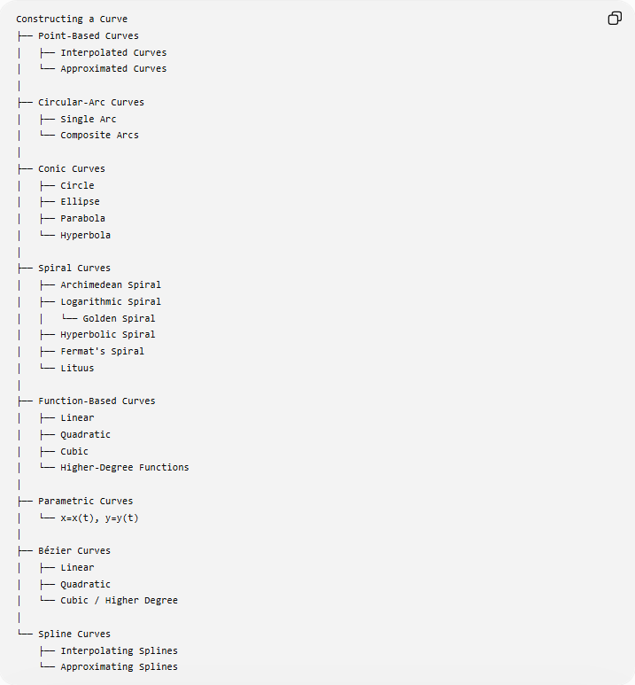
Constructing a Curve
├── Point-Based Curves
│ ├── Interpolated Curves
│ └── Approximated Curves
│
├── Circular-Arc Curves
│ ├── Single Arc
│ └── Composite Arcs
│
├── Conic Curves
│ ├── Circle
│ ├── Ellipse
│ ├── Parabola
│ └── Hyperbola
│
├── Spiral Curves
│ ├── Archimedean Spiral
│ ├── Logarithmic Spiral
│ │ └── Golden Spiral
│ ├── Hyperbolic Spiral
│ ├── Fermat's Spiral
│ └── Lituus
│
├── Function-Based Curves
│ ├── Linear
│ ├── Quadratic
│ ├── Cubic
│ └── Higher-Degree Functions
│
├── Parametric Curves
│ └── x=x(t), y=y(t)
│
├── Bézier Curves
│ ├── Linear
│ ├── Quadratic
│ └── Cubic / Higher Degree
│
└── Spline Curves
├── Interpolating Splines
└── Approximating Splines
Classification note: This is a practical classification of curve construction methods and curve families, rather than one universally standardized mathematical taxonomy of all curves.

Basic Constructions Used
# Source: AI Source: Provided by: [Data Path: Persons Table -> ID Column: 1, Name_En Column: Motasem Essam] -> From: [ChatGPT] on [7/25/2026]
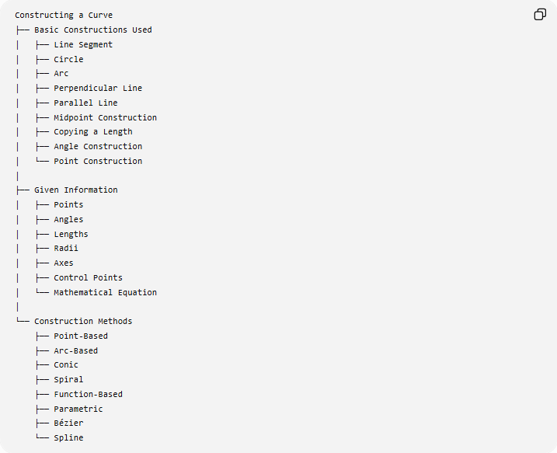
Constructing a Curve
├── Basic Constructions Used
│ ├── Line Segment
│ ├── Circle
│ ├── Arc
│ ├── Perpendicular Line
│ ├── Parallel Line
│ ├── Midpoint Construction
│ ├── Copying a Length
│ ├── Angle Construction
│ └── Point Construction
│
├── Given Information
│ ├── Points
│ ├── Angles
│ ├── Lengths
│ ├── Radii
│ ├── Axes
│ ├── Control Points
│ └── Mathematical Equation
│
└── Construction Methods
├── Point-Based
├── Arc-Based
├── Conic
├── Spiral
├── Function-Based
├── Parametric
├── Bézier
└── Spline

Curve Continuity
# Source: AI Source: Provided by: [Data Path: Persons Table -> ID Column: 1, Name_En Column: Motasem Essam] -> From: [ChatGPT] on [7/25/2026]
When multiple pieces of a curve are joined, the way they meet is important.

1. Positional Continuity
# Source: AI Source: Provided by: [Data Path: Persons Table -> ID Column: 1, Name_En Column: Motasem Essam] -> From: [ChatGPT] on [7/25/2026]
Two curve pieces meet at the same point.
$$\boxed{P_{1}=P_{2}}$$
This is often called $C^{0}$continuity.

2. Tangential Continuity
# Source: AI Source: Provided by: [Data Path: Persons Table -> ID Column: 1, Name_En Column: Motasem Essam] -> From: [ChatGPT] on [7/25/2026]
Two curve pieces meet with the same tangent direction.
This produces a smoother connection.
$$\boxed{\text{Same Point}+\text{Same Tangent Direction}}$$
This is commonly associated with $C^{1}$continuity.

3. Curvature Continuity
# Source: AI Source: Provided by: [Data Path: Persons Table -> ID Column: 1, Name_En Column: Motasem Essam] -> From: [ChatGPT] on [7/25/2026]
The curvature also changes smoothly between the two pieces.
This gives an even smoother transition and is important in advanced engineering and industrial design.

Curve vs Line vs Arc
# Source: AI Source: Provided by: [Data Path: Persons Table -> ID Column: 1, Name_En Column: Motasem Essam] -> From: [ChatGPT] on [7/25/2026]
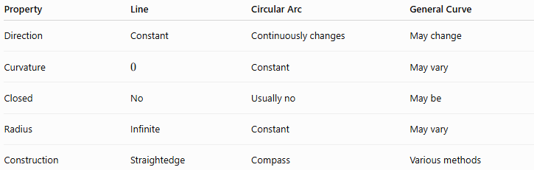
Property | Line | Circular Arc | General Curve
Direction | Constant | Continuously changes | May change
Curvature | $$0$$ | Constant | May vary
Closed | No | Usually no | May be
Radius | Infinite | Constant | May vary
Construction | Straightedge | Compass | Various methods
A circular arc is therefore a particular type of curve.

Curve vs Polygon
# Source: AI Source: Provided by: [Data Path: Persons Table -> ID Column: 1, Name_En Column: Motasem Essam] -> From: [ChatGPT] on [7/25/2026]
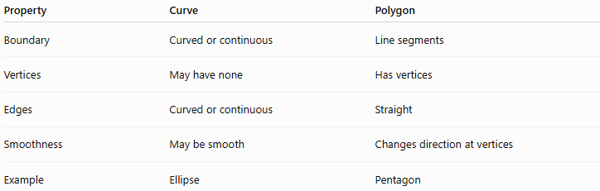
Property | Curve | Polygon
Boundary | Curved or continuous | Line segments
Vertices | May have none | Has vertices
Edges | Curved or continuous | Straight
Smoothness | May be smooth | Changes direction at vertices
Example | Ellipse | Pentagon
A polygon can approximate a curve using sufficiently many small segments, but it is not itself a smooth curve.

Curve vs Freeform Shape
# Source: AI Source: Provided by: [Data Path: Persons Table -> ID Column: 1, Name_En Column: Motasem Essam] -> From: [ChatGPT] on [7/25/2026]
A curve is a one-dimensional geometric object or path.
A freeform shape may consist of:
- Curves.
- Line segments.
- Closed boundaries.
- Multiple connected components.
- Irregular geometric elements.
Therefore:
$$\boxed{\text{Curve}≠\text{Freeform Shape}}$$
although a freeform shape may be constructed entirely from curves.

Example: Constructing a Parabolic Curve
# Source: AI Source: Provided by: [Data Path: Persons Table -> ID Column: 1, Name_En Column: Motasem Essam] -> From: [ChatGPT] on [7/25/2026]
Suppose the curve is:
$$y=x^{2}$$
Choose:
$$x=-2,-1,0,1,2$$
Then:
$$y=4,1,0,1,4$$
Construct the points:
$$\left(- , 24\right), \left(- , 11\right), \left(0 , 0\right), \left(1 , 1\right), \left(2 , 4\right)$$
Then connect them with a smooth curve.
The result is a parabola.

Example: Constructing a Circular Curve
Given center $O$and radius $r$:
- Mark $O$.
- Set the compass to $r$.
- Rotate the compass around $O$.
- Complete the circular boundary.
The defining equation is:
$$\boxed{{\left(x-h\right)}^{2}+{\left(y-k\right)}^{2}=r^{2}}$$
A circle is therefore a specific closed curve with constant curvature.

Applications
# Source: AI Source: Provided by: [Data Path: Persons Table -> ID Column: 1, Name_En Column: Motasem Essam] -> From: [ChatGPT] on [7/25/2026]
Curve construction is used in:
- Geometry.
- Technical drawing.
- Architecture.
- Engineering.
- Mechanical design.
- Computer-aided design (CAD).
- Computer graphics.
- Animation.
- Typography.
- Product design.
- Mathematical modeling.
- Road and railway design.

Key Points
# Source: AI Source: Provided by: [Data Path: Persons Table -> ID Column: 1, Name_En Column: Motasem Essam] -> From: [ChatGPT] on [7/25/2026]
- A curve is a continuous geometric path.
- Curves can be constructed using points, arcs, equations, control points, or geometric constraints.
- A general parametric curve can be represented as:
$$\boxed{P\left(t\right)=\left(x , \left(t\right)y\left(t\right)\right)}$$
- An implicit curve can be represented as:
$$\boxed{F\left(x , y\right)=0}$$
- A polar curve can be represented as:
$$\boxed{r=f\left(θ\right)}$$
- Important curve families include:
  - circular curves,
  - conics,
  - spirals,
  - polynomial curves,
  - Bézier curves,
  - spline curves,
  - freeform curves.
- Smooth joining can require positional, tangential, or curvature continuity.
- A circle, ellipse, parabola, and hyperbola are all specific types of curves.
- A spiral is also a type of curve.
- A freeform curve does not necessarily have a simple standard equation.

Conclusion
# Source: AI Source: Provided by: [Data Path: Persons Table -> ID Column: 1, Name_En Column: Motasem Essam] -> From: [ChatGPT] on [7/25/2026]
Constructing a Curve is the process of creating a continuous geometric path using points, arcs, mathematical relationships, or control elements. Curves range from simple circular arcs and conics to spirals, Bézier curves, splines, and freeform curves. The appropriate construction method depends on whether the curve is defined by a geometric property, mathematical equation, sequence of points, or design requirements.

